
SEMESTER ONE
YEAR 11
MATHEMATICS METHODS
Unit 1
2015
Section Two
(Calculator–assumed)

Name: _________________________________

Teacher: ________________________________

TIME ALLOWED FOR THIS SECTION

Reading time before commencing work: 10 minutes
Working time for section: 100 minutes

MATERIAL REQUIRED / RECOMMENDED FOR THIS SECTION

To be provided by the candidate
Standard items: pens, pencils, pencil sharpener, highlighter, eraser, ruler.

Special items: drawing instruments, templates, notes on up to two unfolded sheet of A4 paper, and up to three calculators approved for use in the WACE examinations.

IMPORTANT NOTE TO CANDIDATES

No other items may be taken into the examination room. It is your responsibility to ensure that you do not have any unauthorised notes or other items of a non–personal nature in the examination room. If you have any unauthorised material with you, hand it to the supervisor before reading any further.

To be provided by the supervisor

Question/answer booklet for Section Two.
Formula sheet retained from Section One.
Structure of this examination

 | Number of questions available | Number of questions to be answered | Working time (minutes) | Marks available | Percentage of exam
Section One  Calculator—free | 8 | 8 | 50 | 50 | 35
Section Two  Calculator—assumed | 11 | 11 | 100 | 100 | 65
Total marks |  |  |  | 150 | 100

Instructions to candidates

1. The rules for the conduct of this examination are detailed in the Information Handbook.
Sitting this examination implies that you agree to abide by these rules.

2. Write your answer in the Question/Answer booklet.

3. You must be careful to confine your responses to the specific questions asked and to
follow any instructions that are specific to a particular question.

4. Spare pages are provided at the end of this booklet. If you need to use them, indicate
in the original answer space where the answer is continued i.e. give the page number.

5. Show all your working clearly. Your working should be in sufficient detail to allow your answers to be checked readily and for marks to be awarded for reasoning. Incorrect answers given without supporting reasoning cannot be allocated any marks. For any question or part question worth more than two marks, valid working or justification is required to receive full marks. If you repeat an answer to any question, ensure that you cancel the answer you do not wish to have marked.

6. It is recommended that you do not use pencil, except in diagrams.

7. The Formula Sheet is not to be handed in with your Question/Answer booklet.

9. (4 marks)
Given the function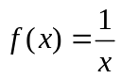, sketch the indicated functions on the same diagrams.

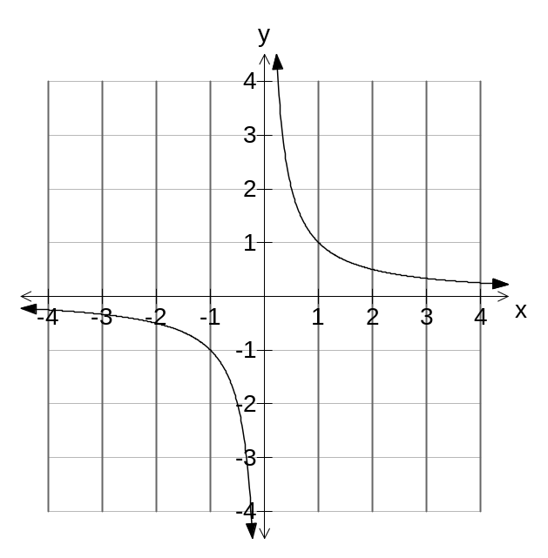 (a) Sketch 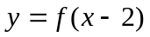 (2)

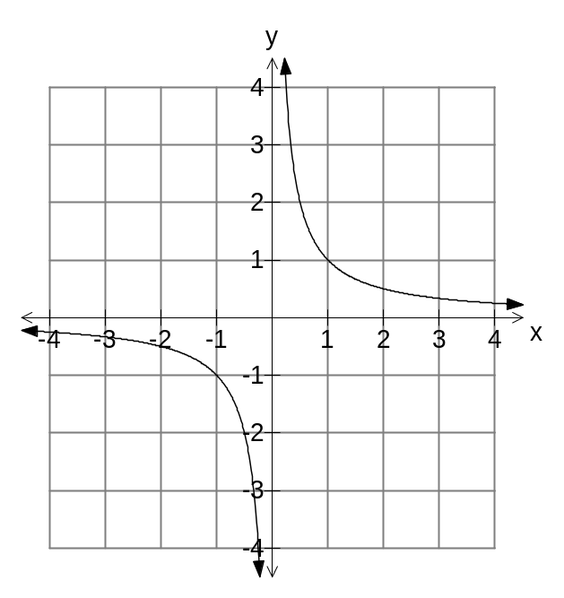 (b) Sketch 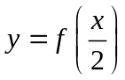 (2)

10. (15 marks)

(a) Find the equation of the relationships graphed below:
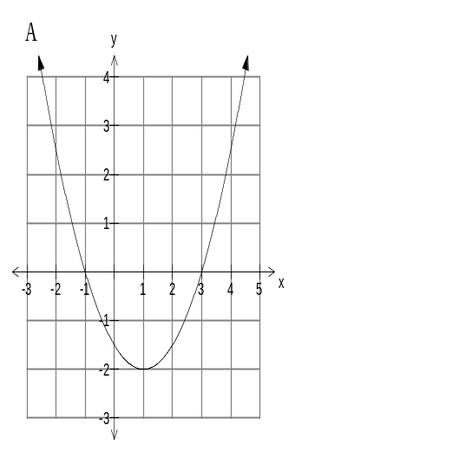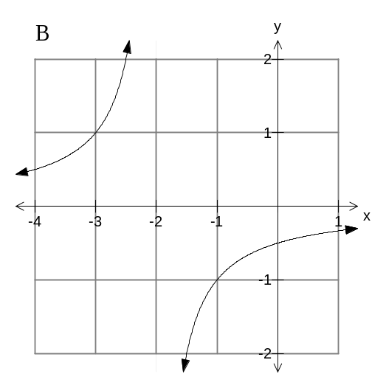

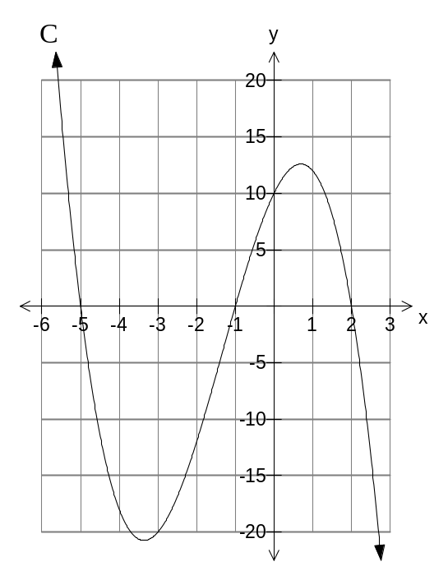
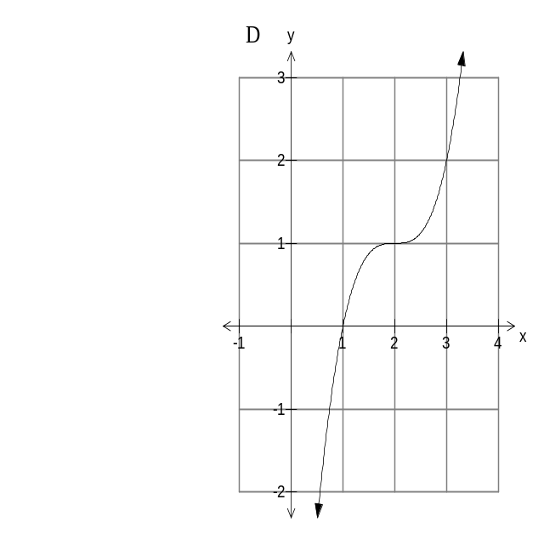

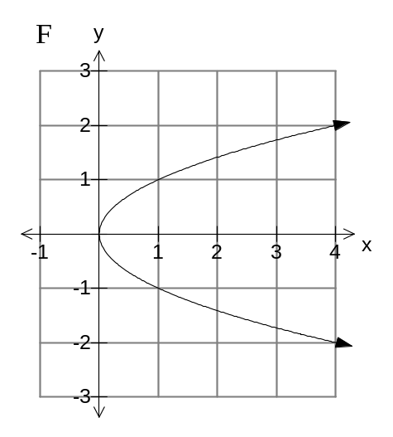

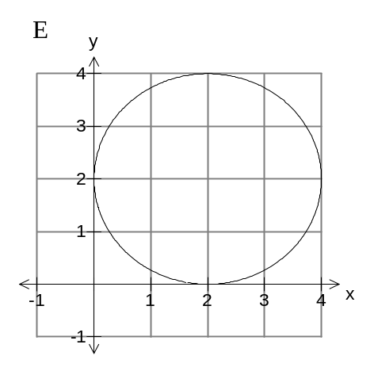

ANSWERS

A _______________________ B _______________________

C _______________________ D _______________________

E _______________________ F _______________________

(1 + 1 + 2 + 1 + 2 + 2 marks)

(b) Which of the relationships in (a) do not represent a function? Explain. (2)

(c) Identify the features P, Q, R and S on the diagram below. (4)
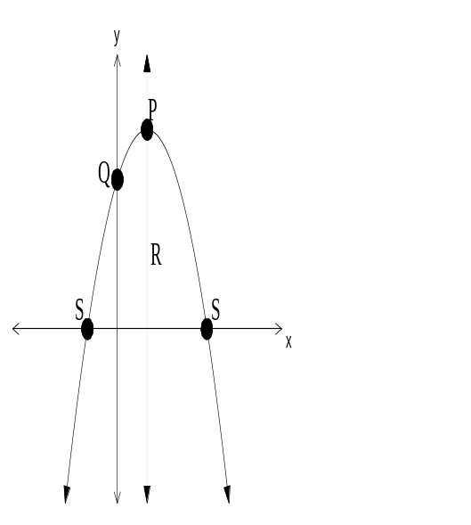

P _______________________

Q _______________________

R _______________________

S _______________________

11. (15 marks)
(a) Solve the following equation by completing the square
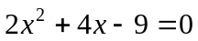.
Leave your answer in terms of surds. (4)

(b) The equation 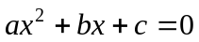 can be solved with the rule 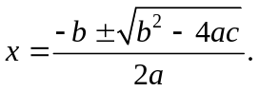
Sketch a representation of the corresponding function 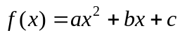
where for the corresponding equation
(i) 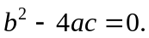 (2)

(ii) 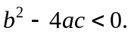 (2)

(c) Solve the following equations correct to two decimal places where appropriate.
(i) 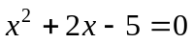 (2)

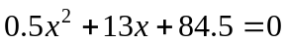
(2)
(ii)

(d) Sketch a cubic function such that there is/are
(i) one zero. (1)

(ii) two distinct zeroes. (2)

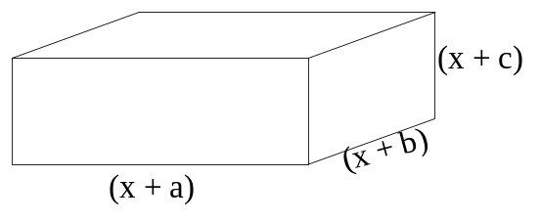12. (5 marks)
The volume of a rectangular based box is given by 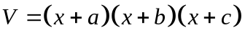
It is known that 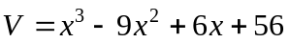.

(a) Use your calculator to determine the values of a, b and c (in any order). (2)

(b) Explain why it is not possible for a box to be formed when x = 6. (1)

(c) Find the dimensions of the box if the volume is 40 cm³. (2)

13. (6 marks)
(a) Find the radius and the coordinates of the centre of the circle:
x² + y² + 2x = 6y +15 (3)

(b) Points A and B lie on the circumference of a circle, centre O and radius 15 cm.
If the minor arc AB subtends an angle of 0.8 radians at O, find
(i) the length of the minor arc AB (1)

(ii) the area of the major sector AOB (2)

14. (11 marks)
(a) Consider the triangle below. The lengths of all sides of the triangle are given.
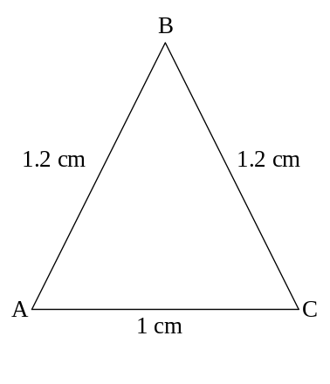
(i) Determine the size of the angle BAC (2)

(ii) Determine the area of the triangle ABC (2)

(b) A second triangle, PQR, has PR = 8, QR = 5 and 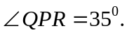
Determine the length of PQ and the size of the angle 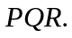 (7)

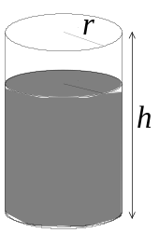15. (8 marks)
A can of soft drink, with radius r and height h, is three quarters
full.

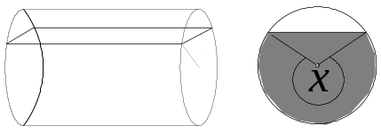 When turned on its side, the can is still three quarters full.

(a) Find the angle x i.e. the angle that subtends the larger segment on the circle.
HINT: Equate two expressions for the volume. (4)

(b) Find the length of the chord at the water level when the can is on its side if the
radius is 3.5 cm. (4)

16. (9 marks)
(a) The curve y= 5^{x} is transformed into y= 5^{x+1} – 1. State the transformations involved. (2)

(b) Amoeba in a petri dish multiply under laboratory conditions according to the rule 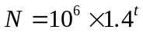where t is the hours from the first estimate of the number of amoeba.
(i) Find  when . (1)

(ii) Find when 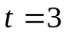. (1)

(iii) How long does it take for to
(i) double? (2)

(ii) treble? (1)

(iv) Estimate 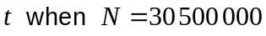. (2)

17. (5 marks)
(a) Calculate 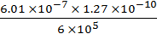 and write the answer in
Scientific notation, rounded to two significant figures (2)

(b) The numerator of a fraction is 3 more than the denominator. The sum of the numerator and the denominator is 11.
(i) Write two simultaneous equations from this information (1)

(ii) Hence, determine the fraction (2)
18. (12 marks)

(a) Consider the data in the two way table below:

 | R | S | T
M | 0.3 | 0.2 | 0 | 0.5
Q | 0.1 | 0.2 | 0.2 | 0.5
 | 0.4 | 0.4 | 0.2 | 1

(i) Determine 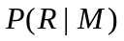 (2)

(ii) Determine 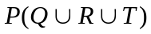 (1)

(iii) Find two events that are mutually exclusive.
Support your answer with appropriate reasoning. (1)

(iv) Explain why the events M and S are independent. (3)

(b) Determine 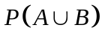 given 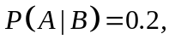 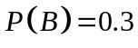and that A and B are
independent. (3)

(c) Given 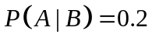 and 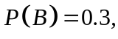explain why A and B cannot be
mutually exclusive. (2)

19. (10 marks)

It was widely believed that a certain health food, if taken daily, eradicated the symptoms of colds after a few days, otherwise the symptoms would last a week.

To study the effectiveness of the health food, a survey was done of 200 people who had developed a cold. The results are as follows.

- Sixty of the people taking the survey had taken the health food and of these,
36 felt they had lost the cold symptoms in four or less days.

- Of the remaining 140 people, 60 still had the cold symptoms for more than four days, often longer.

Let represent the people who had taken the health food daily, and let 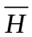represent those who did not take the health food daily.

Let represent those people who still had the symptoms for more than four days.

(a) Complete the tree diagram using relative frequencies obtained from the
information above. (4)
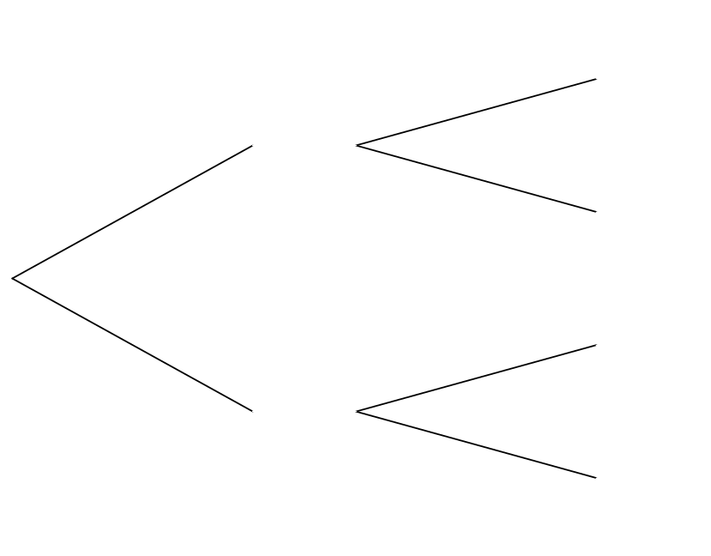
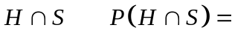

(b) (i) Determine 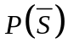. (1)

(ii) Determine 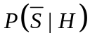 (2)

(c) Use the results of (b) to decide if in fact the health food had any effect on the length of
the symptoms of the cold. (3)

END OF SECTION TWO
Extra page for working if necessary

